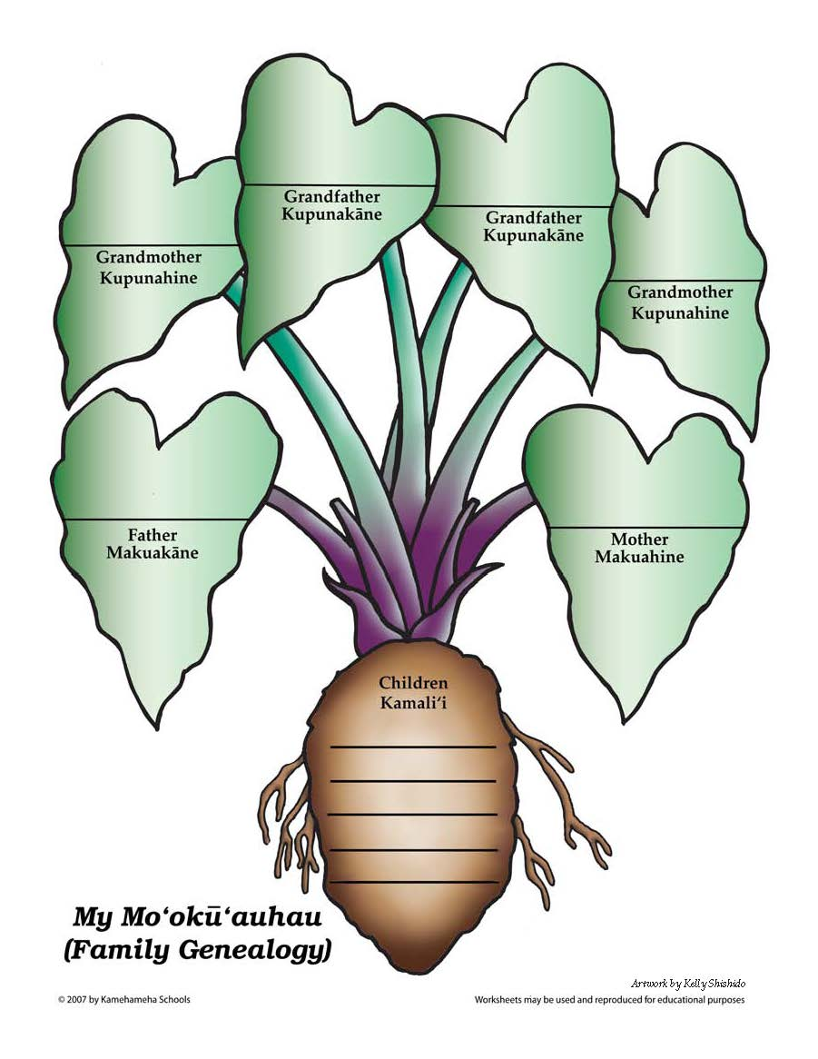

**HAWAI’I’S DAUGHTER’S GUILD**

**IS HOSTING A GENEALOGY WORKSHOP WITH KU’ULEIMOMI NAKILA**

**ON MARCH 30, 2019 FROM 11 AM TO 3 PM AT THE CHURCH OF JESUS CHRIST OF LATTER DAY SAINTS**

**2000 ARTESIA BLVD, TORRANCE, CA. 90504**

**$ 15 for Starter Kit and Lunch**

-----------------------------------------------------------------------------------------------------**REGISTRATION FORM**

**NAME: __________________________________________________________________________________**

**PHONE # ________________________________________________________________________________**

**EMAIL ADDRESS: _______________________________________________________________________**

**________________________________________________________________________________________________________________________**

**I, _____________________, the undersigned, an adult 18 and over, having chosen to participate in this workshop and it’s activities sponsored by the Hawai’i’s Daughter’s Guild, agree to release and hold harmless the Hawai’i’s Daughter’s Guild, the instructor Ku’uleimomi Nakila and the facility from any liability for any harm, accidents, personal injuries, or property damage that I/we may have incurred while participating in the above mentioned workshop. Furthermore, I agree to obey the facility rules and take full responsibility for any damage I may cause to the facility.**

**Print Name: __________________________________________ Signature: ____________________________________________**

**Any questions call: Leo’okalani Nakila 310-525-0308.**