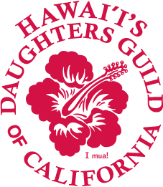**Hawai`i’s Daughters Guild of California**

2020 Holokū Ball

Program Advertisement

Please complete all information below and submit “camera ready” artwork. Artwork is acceptable in hard copy, jpeg and pdf format and may be emailed to: [lei-low@att.net](mailto:lei-low@att.net).

For more information, please contact Marcella Low 310-200-7662.

Please make all checks payable to:

Hawai`i’s Daughters Guild of California

Program Advertisement

111 E. Carson St., Suite 8 PMB 300

Carson, CA 90745

|  |
| --- |
| COMPANY NAME: _______________________________________________  ADDRESS: ______________________________________________________  CITY_____________________________STATE _________ ZIP ____________  PHONE: _________________________EMAIL: _________________________  CONTACT PERSON: ______________________________________________ |

|  |  |  |
| --- | --- | --- |
| AD SIZE | PRICE | √ Ad Space Desired |
| Full Page – 8.5 x 11 | $250 |  |
| Half page – 5.5 x 8.5 | $100 |  |
| ¼ page – 5.5 x 4.25 | $50 |  |
| Business card | $25 |  |

**DEADLINE MARCH 1, 2020**